Mercy Health - External candidate application guide
This guide is designed to assist external candidates when applying for vacancies with Mercy Health.

Apply for a position

- Navigate to the Mercy Health careers site - https://mercyhealth.mercury.com.au/Default.aspx
- Click All Vacancies.
All current Mercy Health vacancies will be displayed.
- You can search for a specific position, or you can filter positions by various categories.
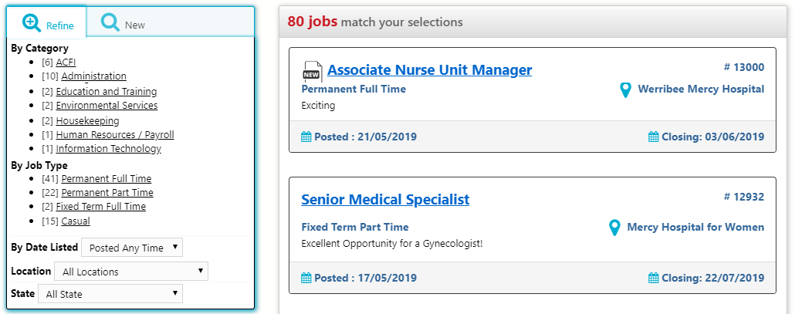
- Click the position you wish to apply for.
The Position Details screen will display with information about the position, including the position description, which can be downloaded.
- At the bottom of the page, click Apply Now.
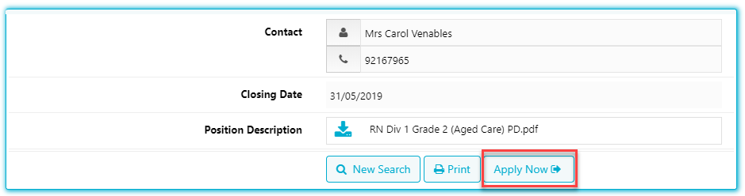
- At the next page, you will be prompted to enter your email address. Click Apply Now.
The Application for Position screen will display.
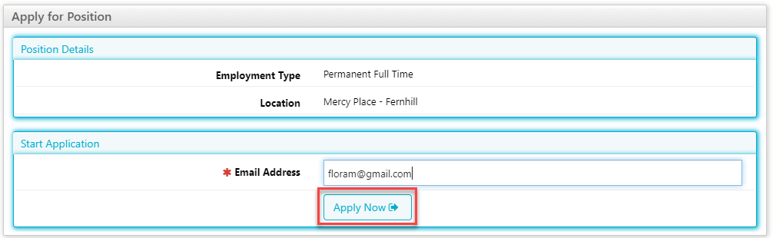

- Enter your details at each of the screens below. Some fields are mandatory and you cannot progress your application without entering the required information.
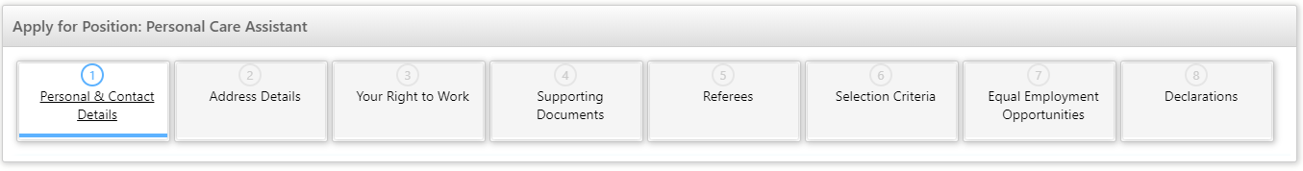
- The Declarations page will allow you to Submit your application.
Upon submission, you will receive an email acknowledging your application.
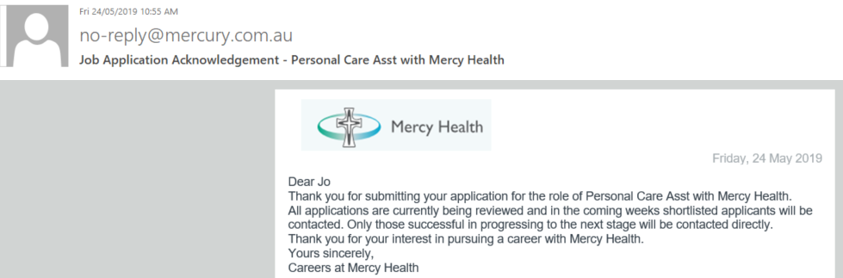

Manage your profile

Once your application has been submitted, you will receive an email as below:
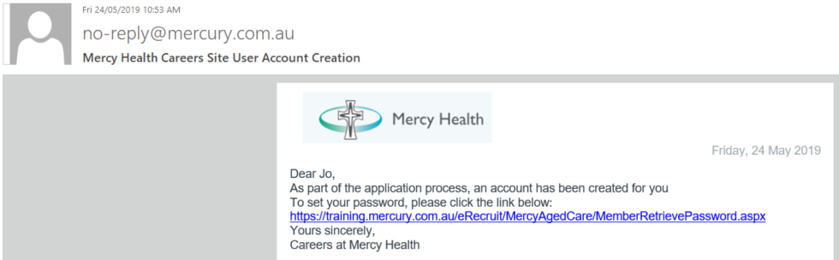
- Click the link in the email to activate your account.
The Forgotten Password / Username screen will display.
- Enter your password and click Submit.
An automated email is sent to your account with your username and a link to reset your password.
- Click the link in the email to reset your password.
The Mercy Health eRecruit site will be displayed.

- Enter the password you wish to use for your account. Click Continue.
Your Mercy Health password has been set.
- Click Login to view your profile by entering your username and password.

- Click My Profile to view your profile.
Your Mercy Health profile will display.
You can view and update your Mercy Health applications by selecting the Application History tab on your profile.
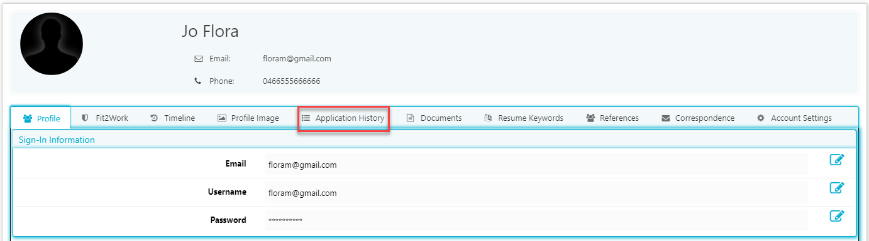

You also have the option to select the job categories that are of most interest to you.
- Click Account Settings and check the box of all categories that appeal to you.
- Click Save.
You will automatically receive an email notification whenever a new position is advertised in one of your preferred job categories.
